动态文本台词
- 接受第一个新任务包以后，主角台词：“Here we go again.”。点击Work1（TextInfoMissionSystem）后消失

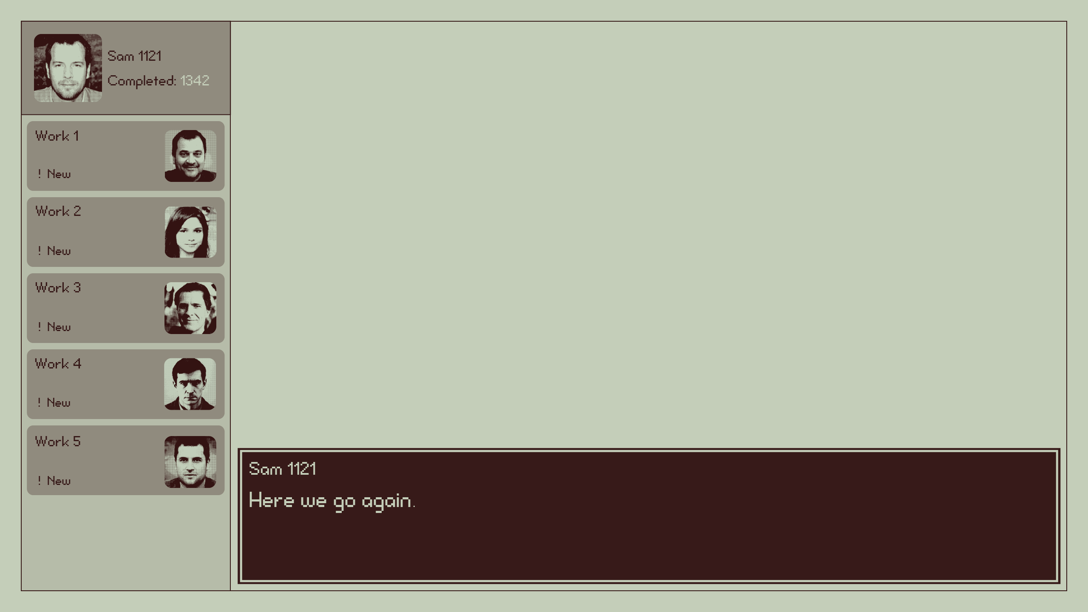

- Work1：
- 首次点开Work1（TextInfoMissionSystem）后显示台词：“Pushing things they might be interested in, boring. ”。
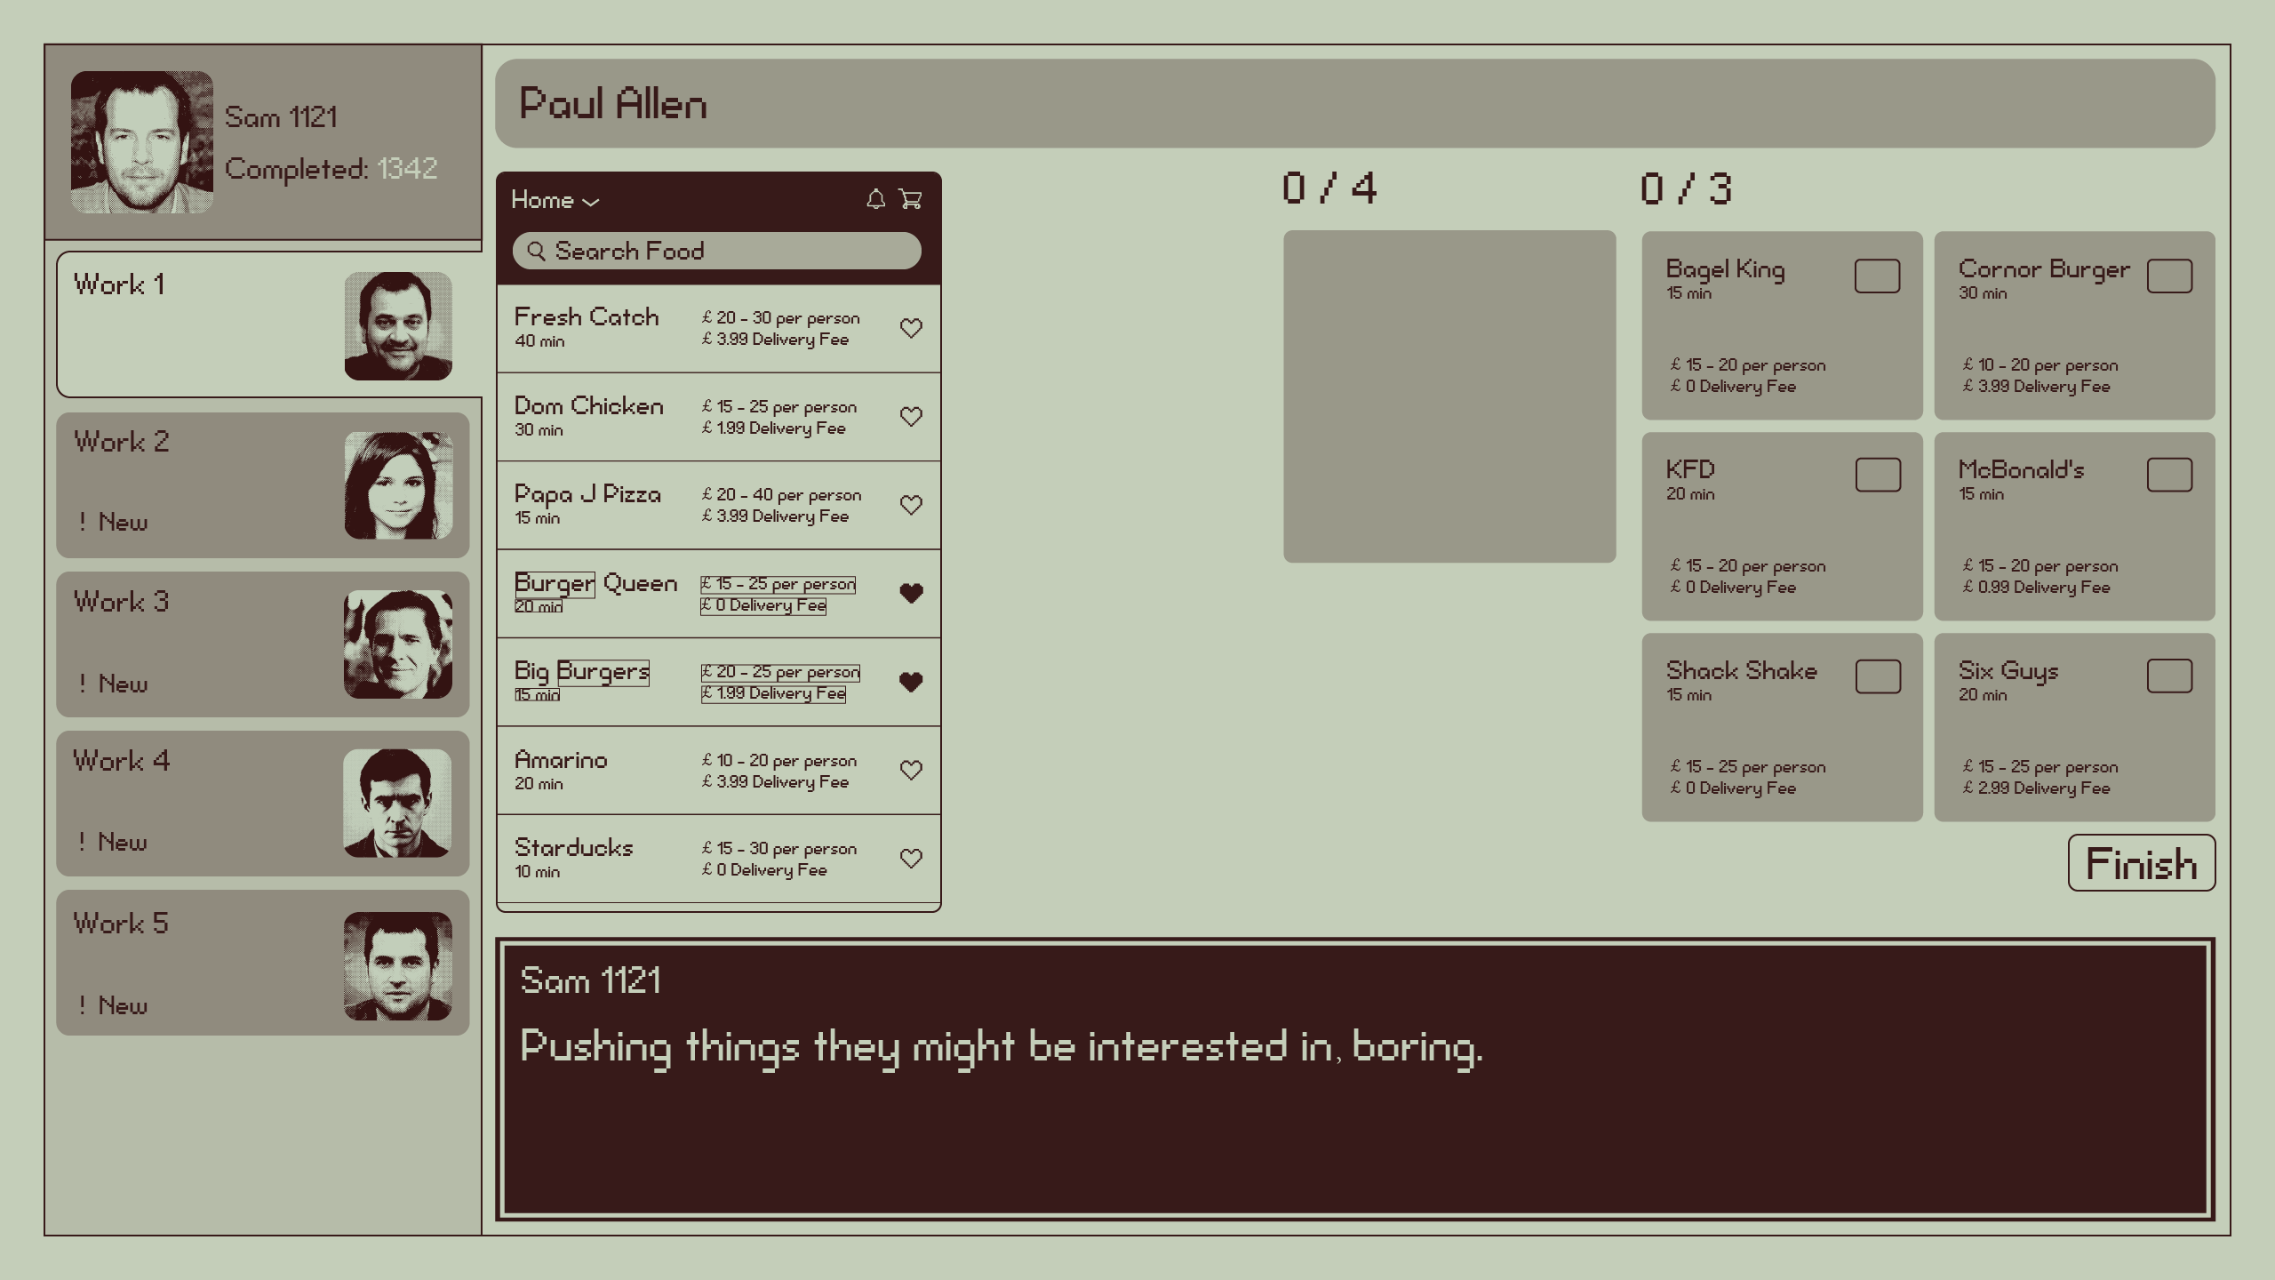

- Work1任务任意点击一个线索后显示台词：“It’s so easy to choose these 8 key similarities.”。点出3个线索后消失

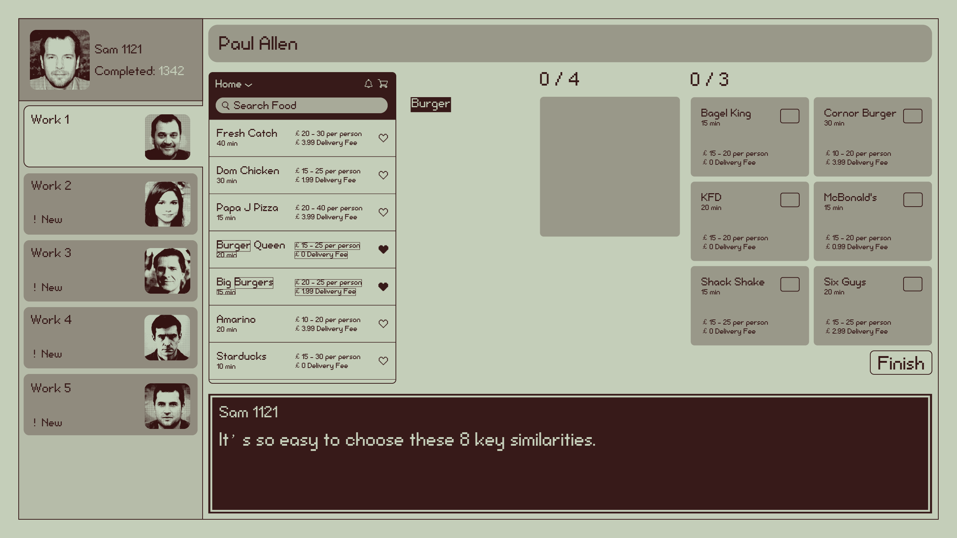

- 首次八个关键词都点完以后显示台词：“Choose 3 restaurants that match the criteria for this hungry man.”
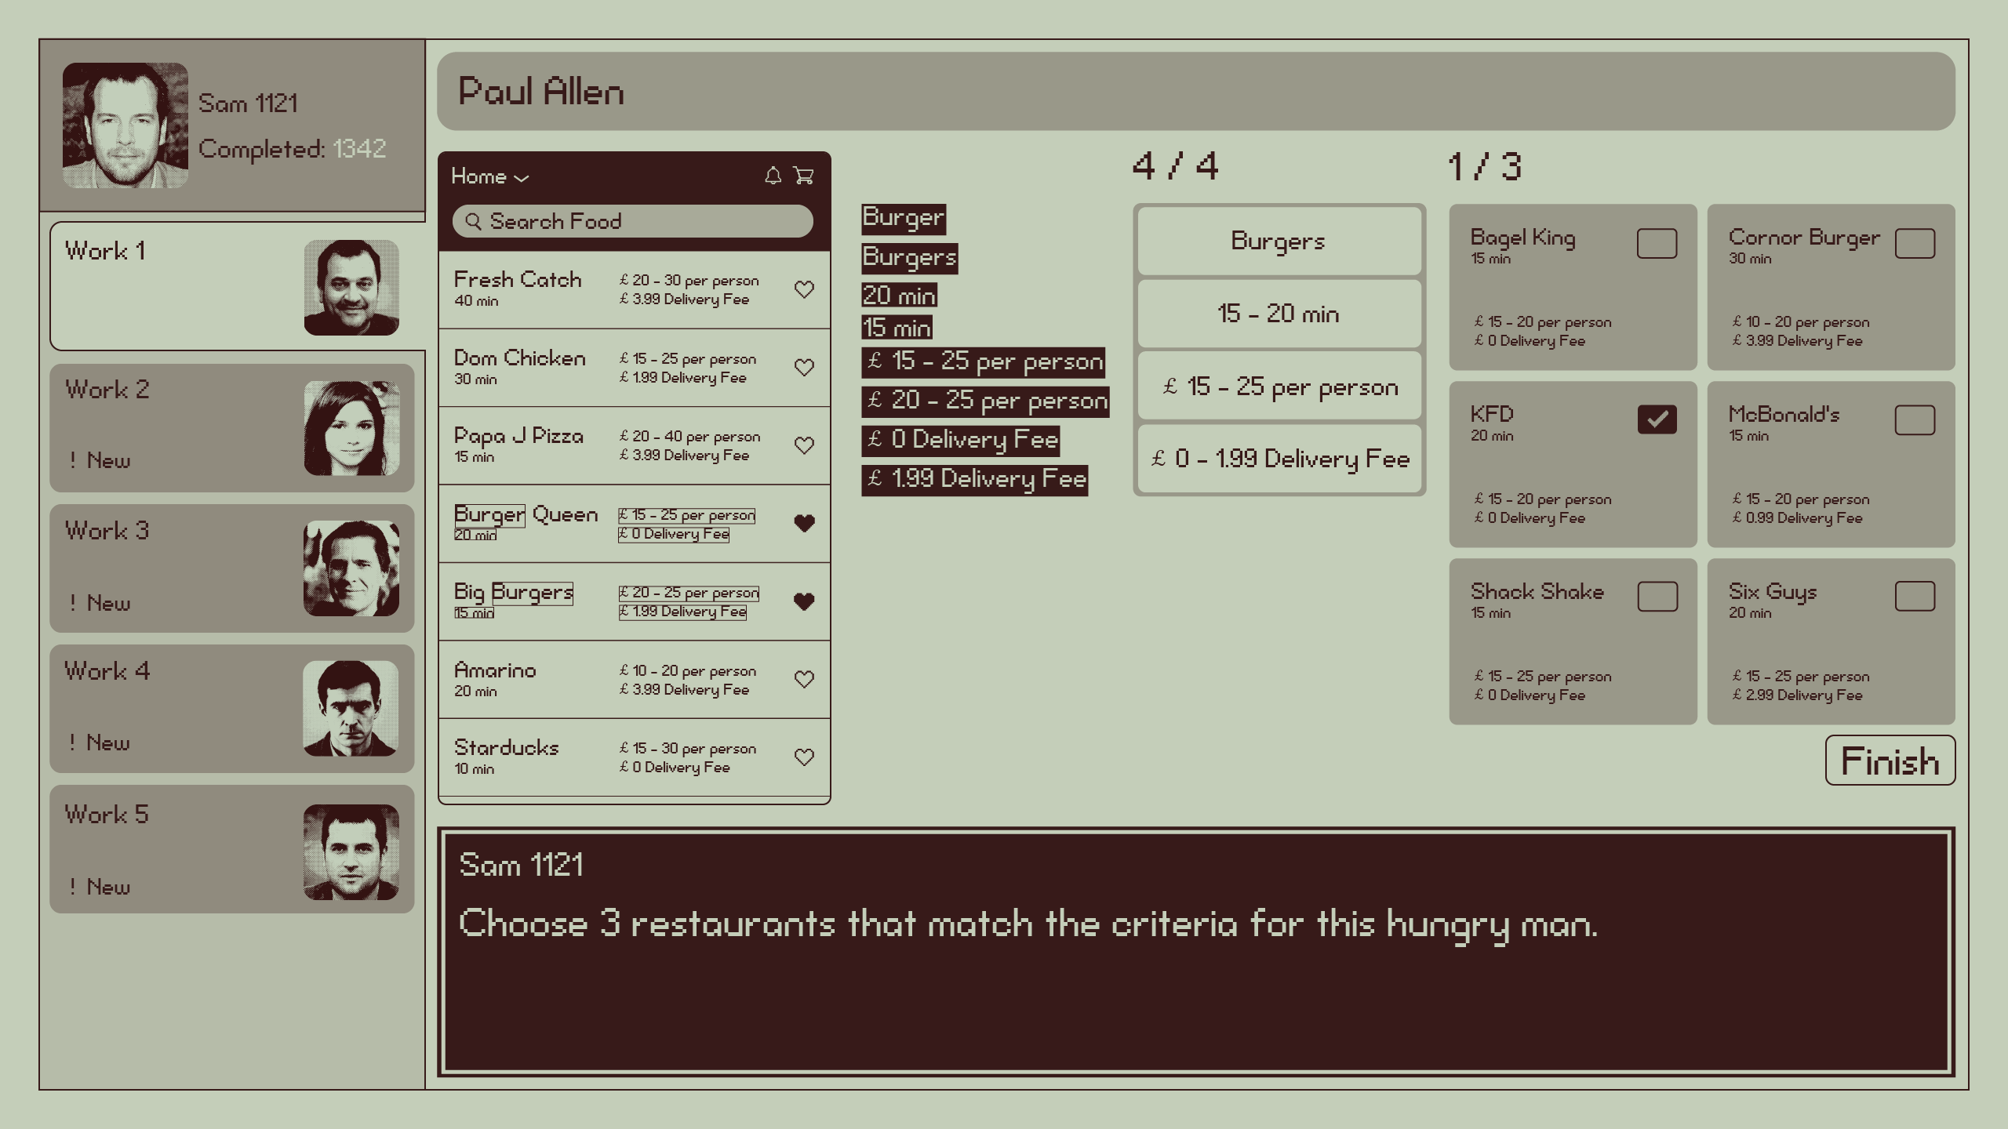

- 首次八个关键词都点完以后并且勾选上右边任意三个餐厅以后显示台词：“Now Submit.”。点击Finish按钮后消失

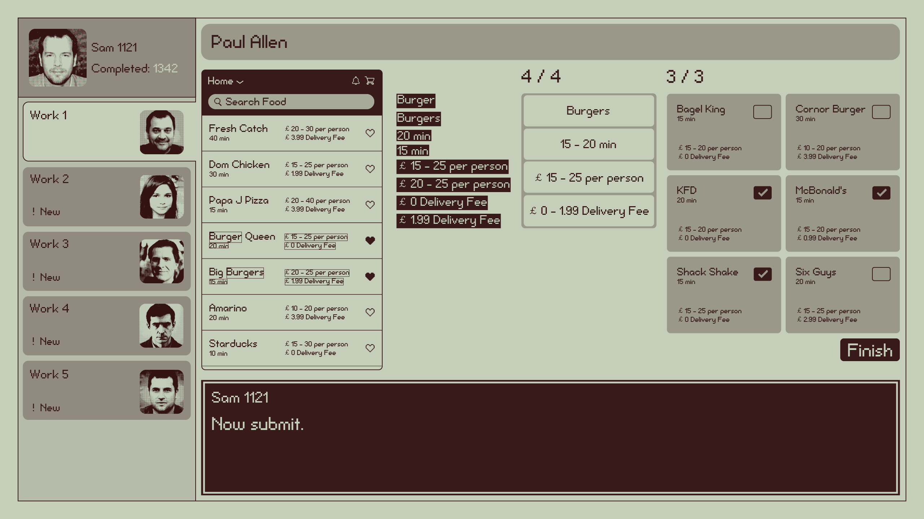

- Work2：
- 首次点开任务后显示台词：“Listen to what they are saying.”。播放完毕后消失

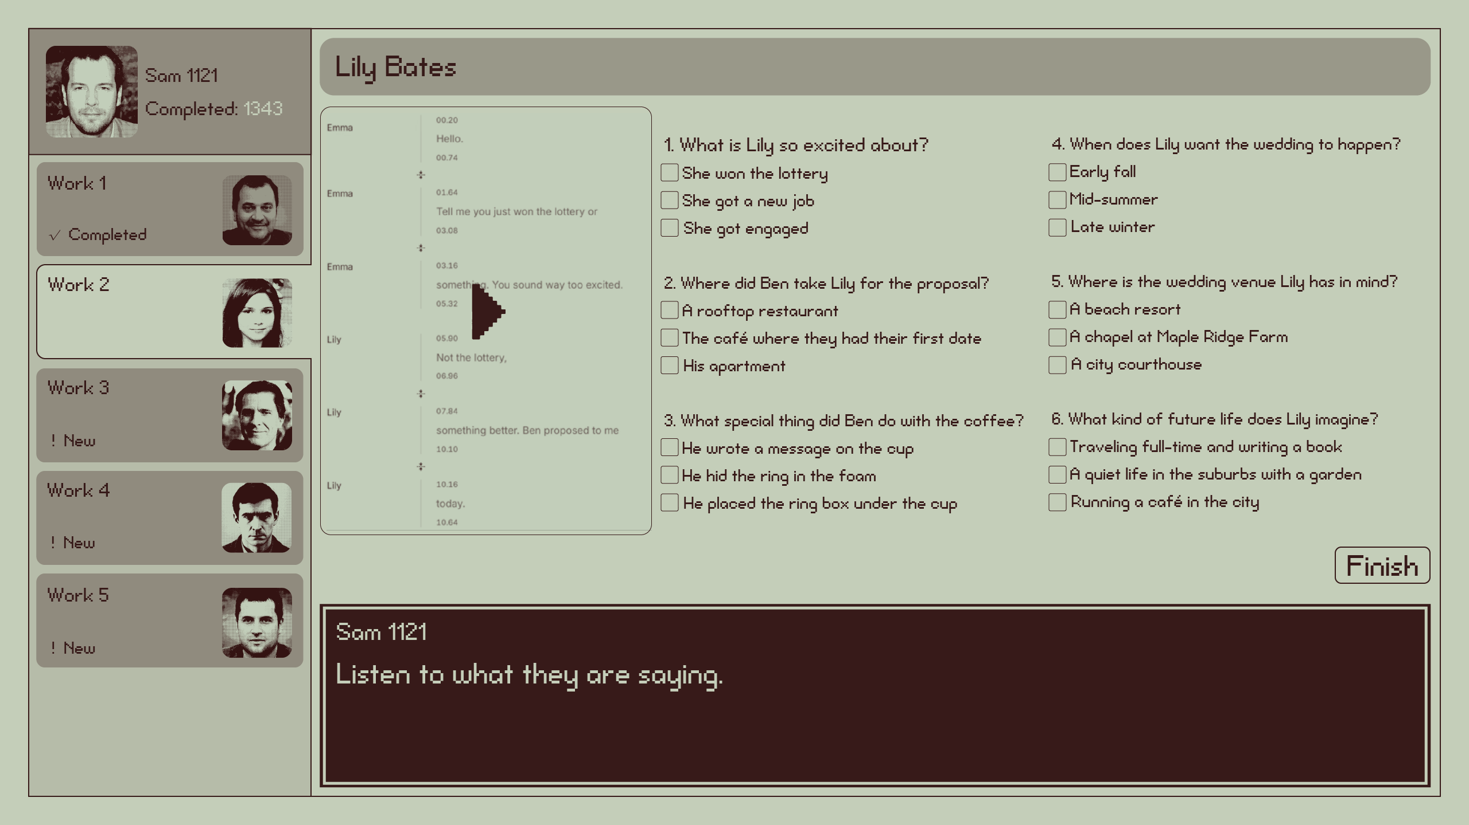

- 首次勾选6个选项以后显示台词：“Lovely！”。点击Finish按钮后消失
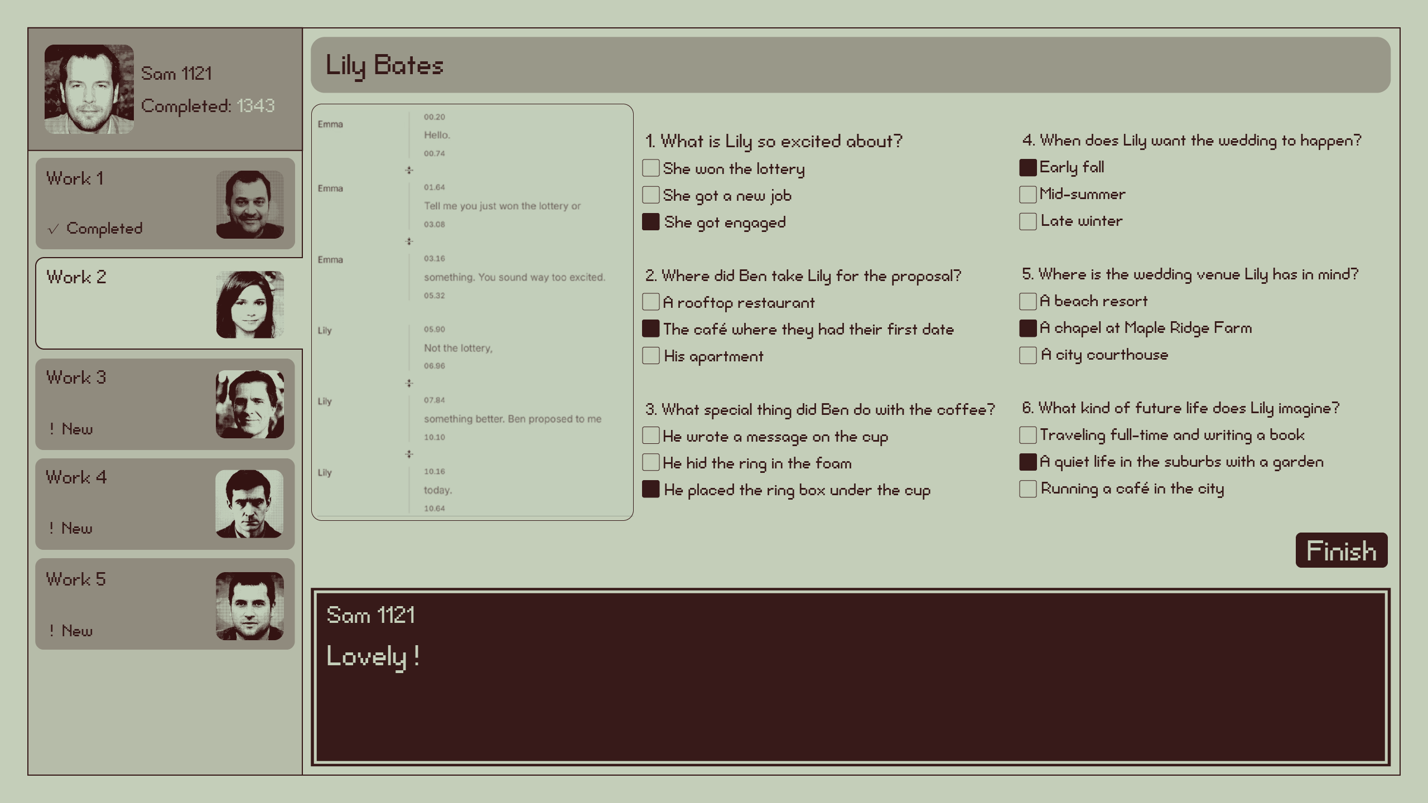

- Work3
- 首次打开任务后显示台词：“Hold on, that' s my number plate. David, you having a laugh?”
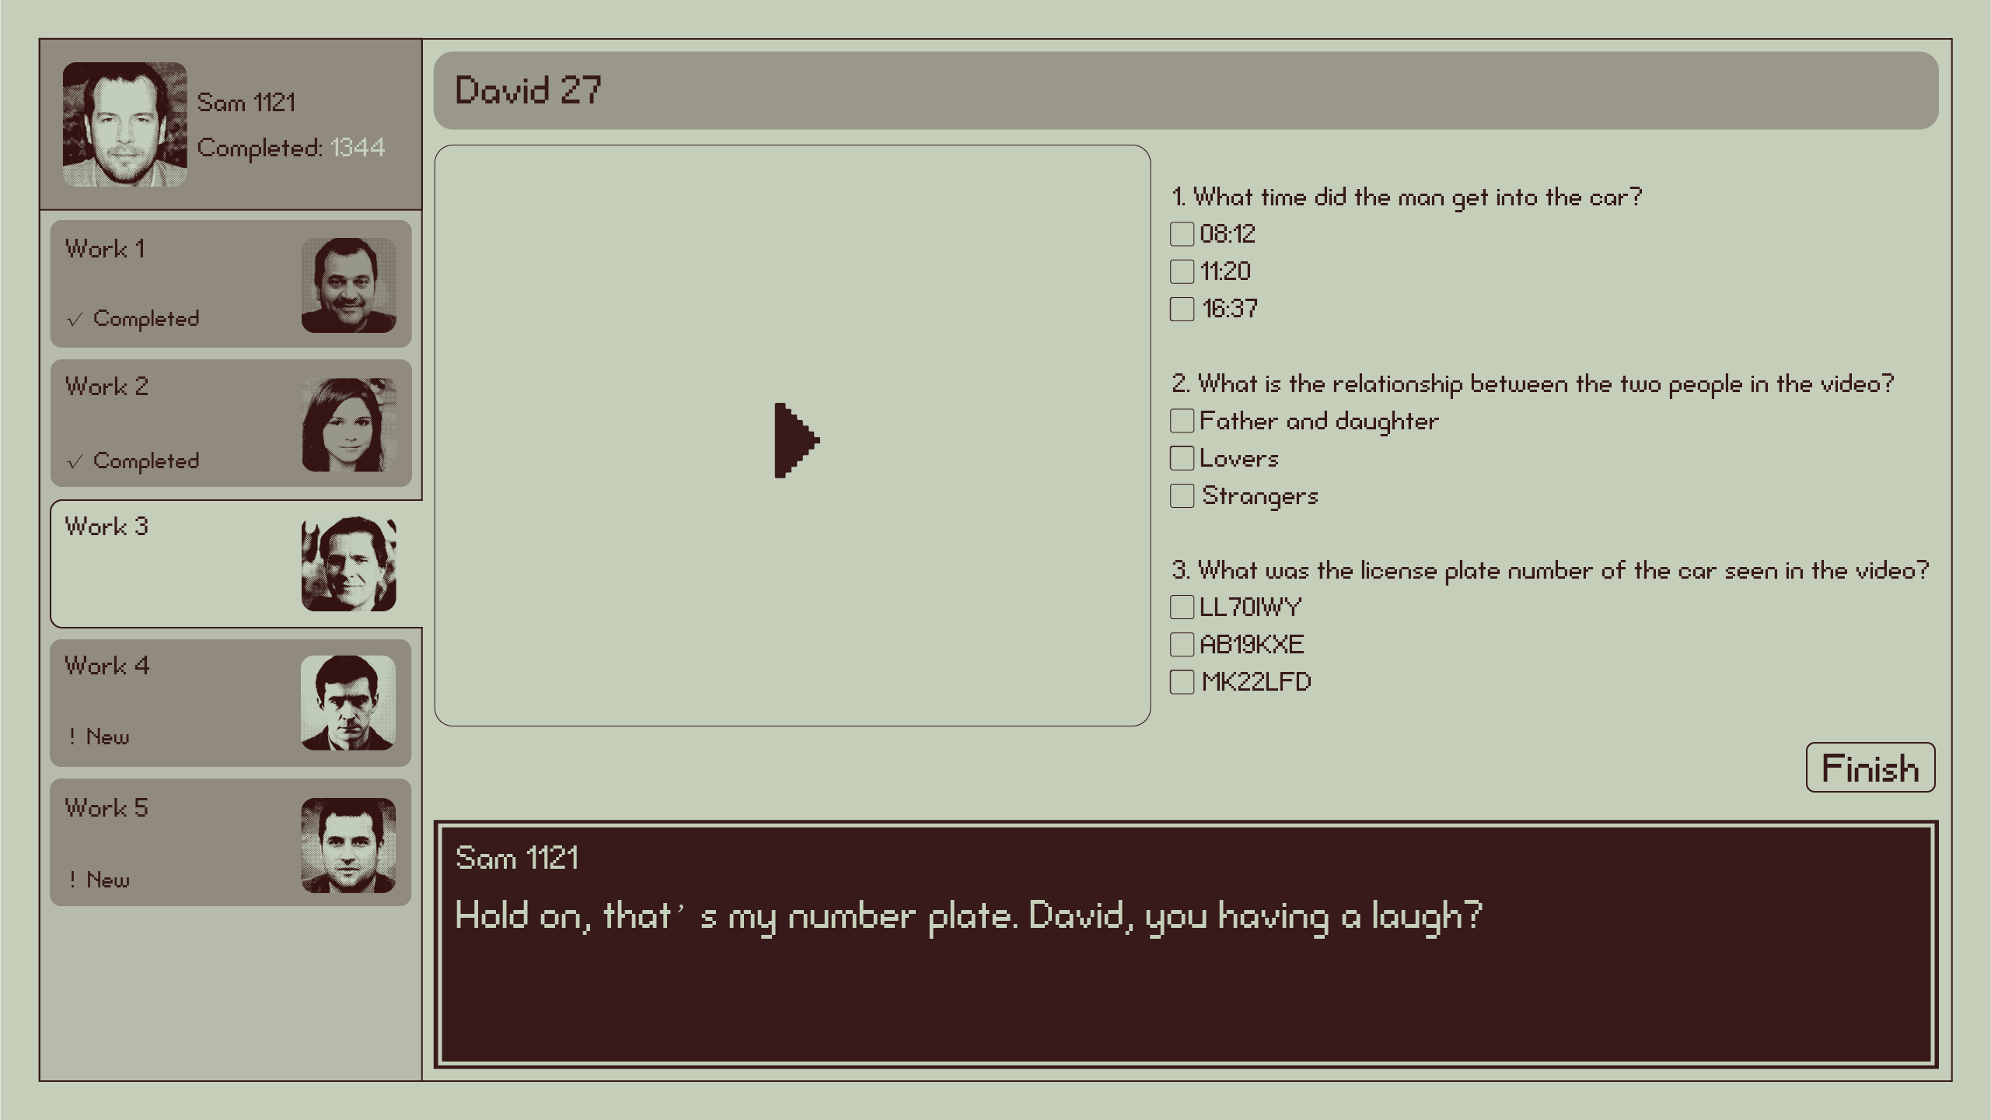

- 视频首次播放到主角老婆出现（大约视频时间35%时）显示台词：“Wait-no. That's... that’s my wife. Driving our car. What the hell's going on?”
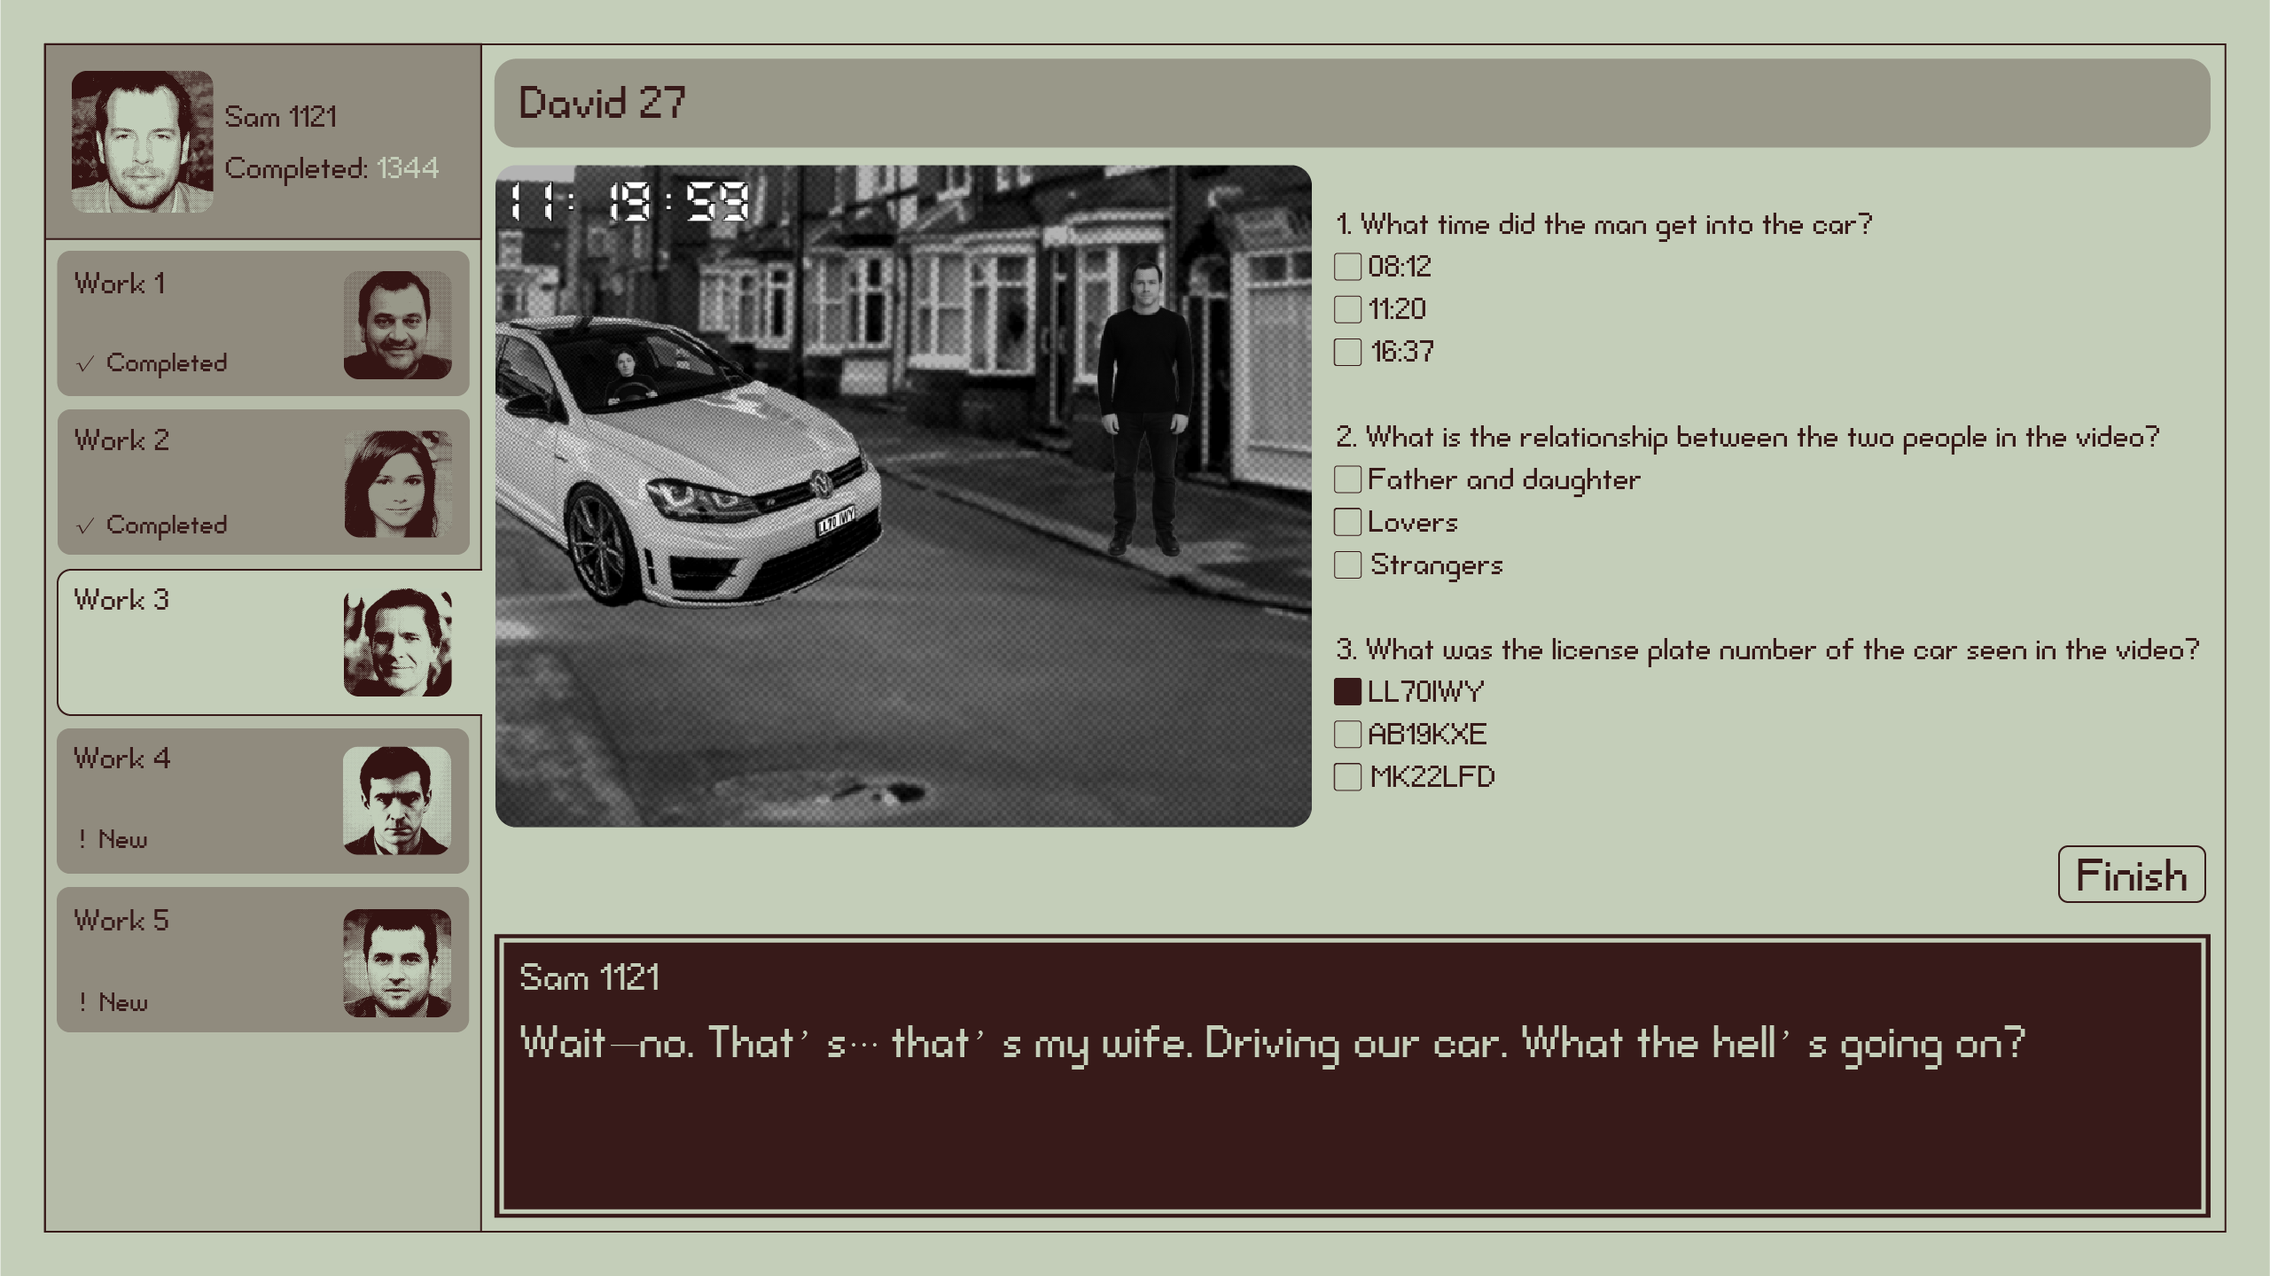

- 视频首次播放到主角老婆和陌生男子亲吻（大约视频时间70%时）显示台词：“Jesus Christ... he' s getting in... they' re kissing. What the bloody hell is this? My head's all over the place.”
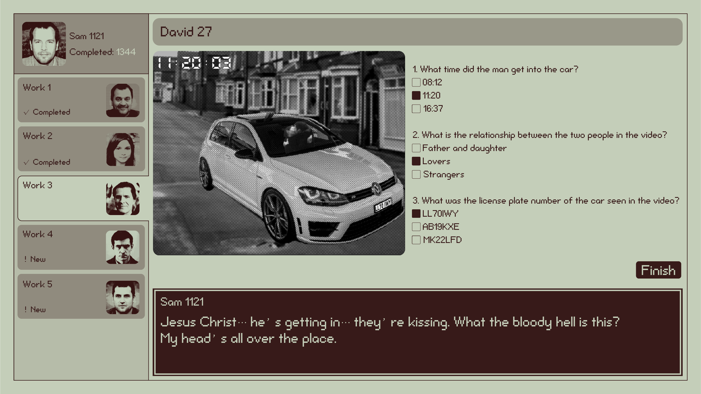

- Work3中，首次任务正确显示台词：“Brilliant. Don' t know what' s real anymore-work, home, none of it makes sense.”
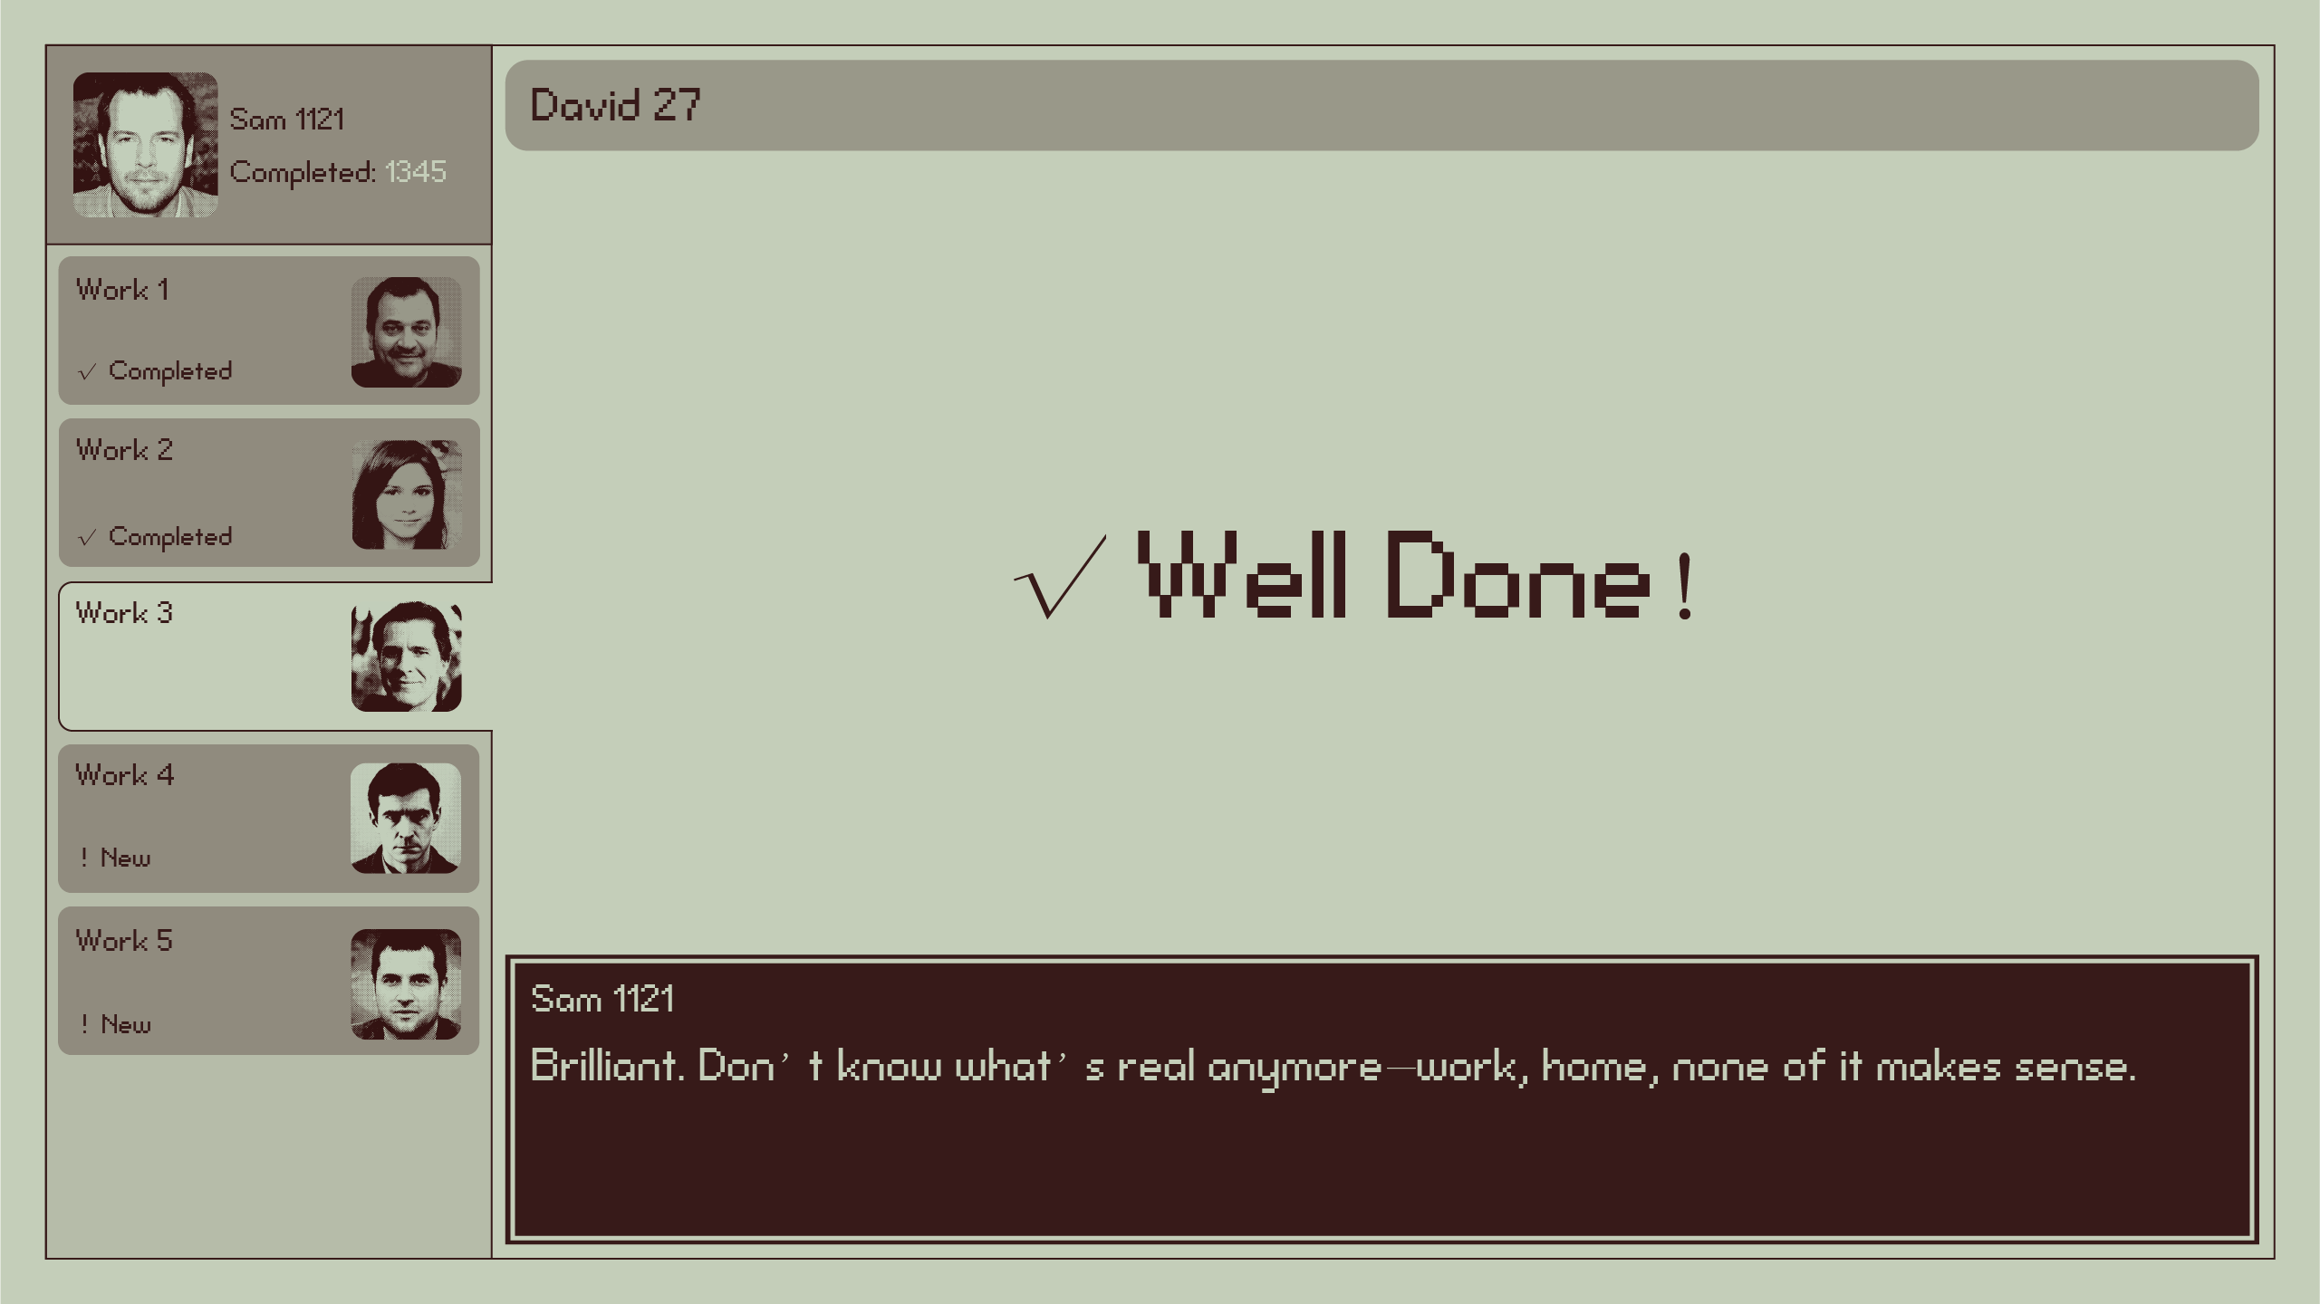

- Work3中，首次任务错误显示台词：“It' s all blurring together now. The mission, my marriage, me... nothing feels solid.”
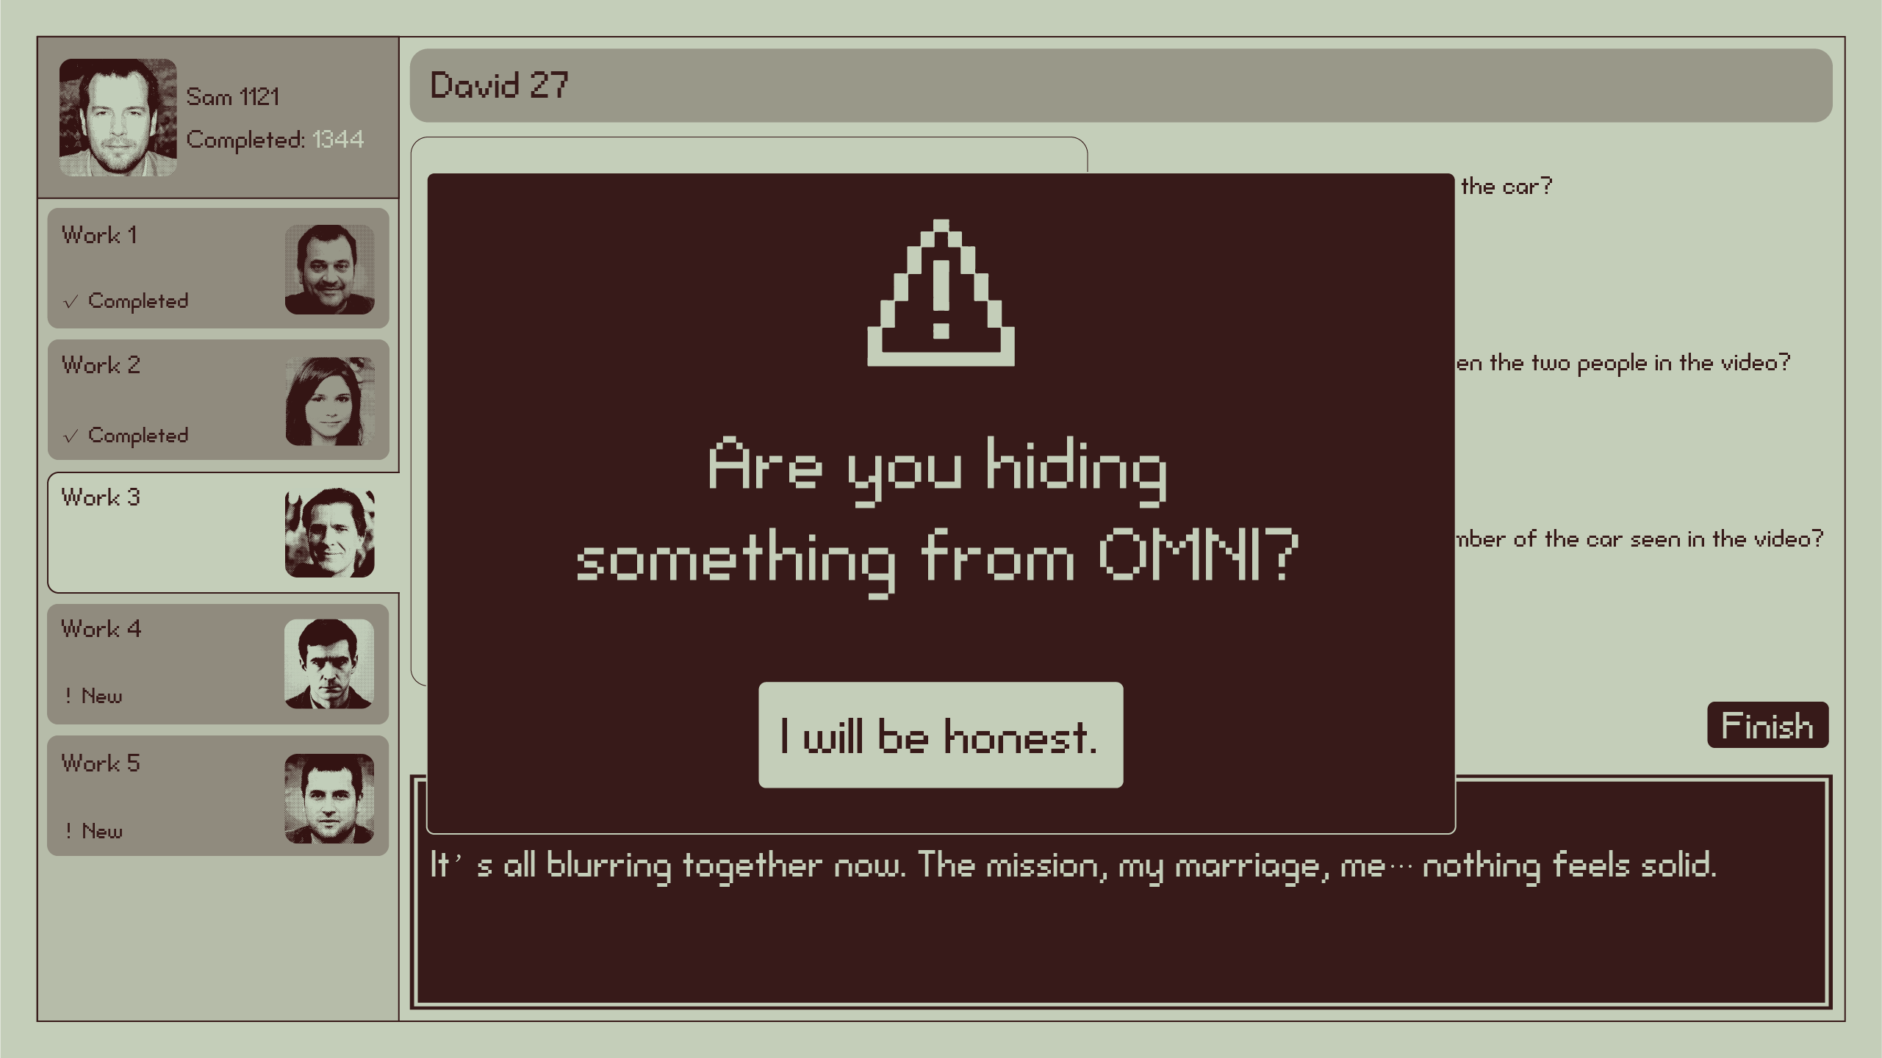

- Work4
- 首次打开任务以后显示台词：“Mess in my chest, but I' ve still got a job to finish. No point stopping now.”。首次点击红点后消失
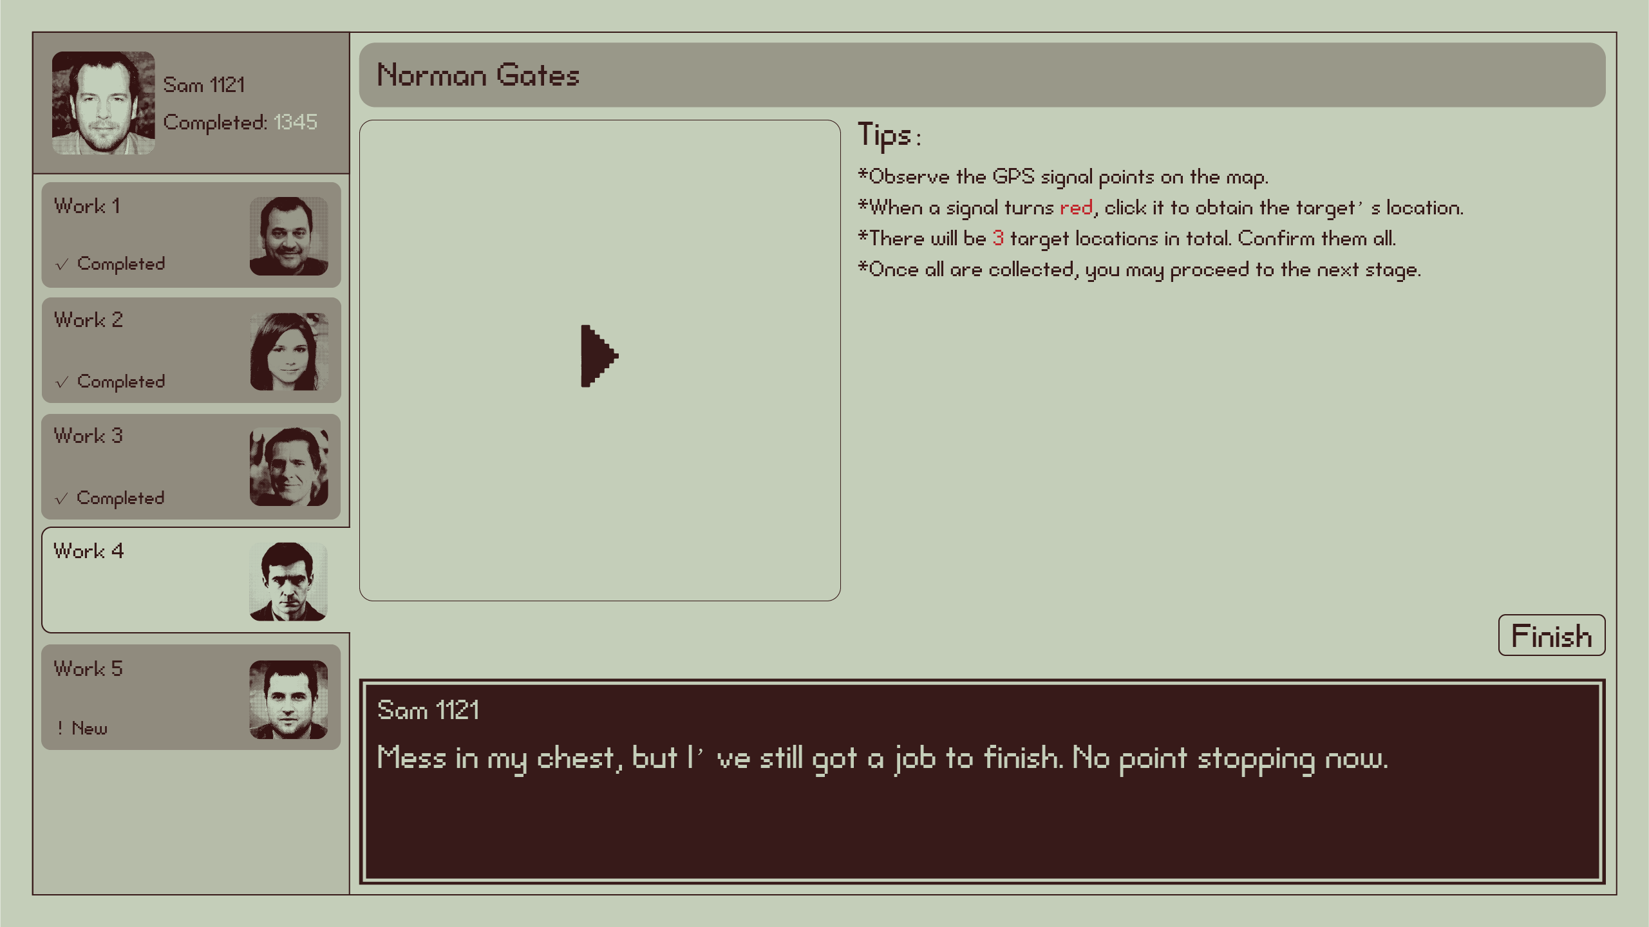

- 首次完成任务后显示台词：“OK.”
